

NATIONAL SKILL TRAINING INSTITUTE (NSTI) KOLKATA, DASNAGAR, HOWRAH

LESSON PLAN
NAME: Ankita singh
TRADE/ROLL NO: CITS/CSA 25-26/Y/1416
UNIT/LESSON NO. 2 DATE & TIME : 22/09/25
- PREPARATION

TITLE/TOPIC:

OBJECTIVES

- Basic concept of how multiple network connects and communicate i.e. “ Internetworking “.
- To develop knowledge about internetworking devices and protocols.
TEACHING AIDS :
WHITE BOARD , MARKER , PROJECTOR , PPT. PENDRIVE ETC.

INTRODUCTION :
MOTIVATION: Lets begin with real-life situation :
“ When you send an email to someone in another city or use google meet , how does your computer connects to theirs?
- PRESENTATION :
OBJECTIVES | INFORMATION POINTS | SPOT HINTS
- OC | 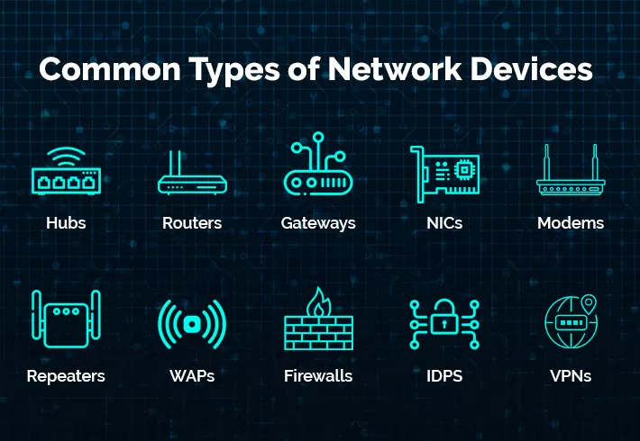  Internetworking is the process of connecting multiple computer networks together using devices like routers and switches so that they can communicate and share resources.  In internetworking, communication between different networks requires a set of rules that define how data is transmitted, received, and interpreted.  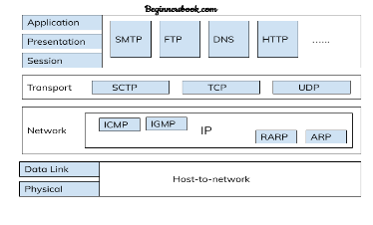  These rules are called protocols. | e.g Imagine a company with :  One office in Delhi  Another in Mumbai  Both offices connected via Internet ( WAN)  Common internetworking devices are –  Hub, router, gateways , Modem, repeater, etc.  e. g. TCP, IP, UDP, ICMP, ARP etc.
- APPLIC ATION :
a) What is internetworking ?
b) Explain the components of internetworking?
c) What is the need of internetworking ?

SUMMARY : To repeat the objectives/main points once again.

- TEST/QUESTIONS :
- What is the work of router?
- Explain the function of internet protocol?
- ASSIGNMENT: Draw a labelled chart on protocols used in internetworking .

Reference :

NEXT LESSON: IPV4

   with

NATIONAL SKILL TRAINING INSTITUTE (NSTI) KOLKATA, DASNAGAR, HOWRAH

INFORMATION SHEET

TITLE/TOPIC:

INFORMATION: nternetworking is the process of connecting different computer networks to form a larger, interconnected network, allowing devices from separate networks to communicate with each other. This is achieved through intermediary devices like routers and gateways, which route data packets across the various networks using protocols like the Internet Protocol (IP). The most well-known example is the Internet, which is a global internetwork of networks.
How it works
- Interconnection:
Internetworking connects distinct networks, such as multiple local area networks (LANs), into a single, larger network.
- Intermediary devices:
Routers and gateways are essential for internetworking, as they operate at the boundaries of networks and can convert data packets from one network's format to another.
- Protocols:
A common set of protocols, such as the TCP/IP suite, provides a unified addressing system and rules for packet formatting and routing, enabling seamless communication across different underlying network technologies.
- Data transmission:
When data is sent, it travels through these interconnected networks, with routers determining the best path for the packet to reach its destination.
Key concepts
- Internetwork:
The resulting system of interconnected networks is called an internetwork or simply an "internet".
- Catenet:
An older term for an internetwork was "catenet," a shortened version of "concatenating" networks.
- Security:
Essential security measures like firewalls, encryption, and VPNs are used to protect data as it travels across the internetwork.
- Internetworking - Wikipedia
Internetworking is the practice of interconnecting multiple computer networks. Typically, this enables any pair of hosts in the co...

Wikipedia
- Introduction of Internetworking - GeeksforGeeks
8 May 2025 — Internetworking is composed of 2 words, inter and networking, which implies an association between totally different nod...

GeeksforGeeks
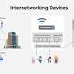
- Internetworking in Computer Network - BYJU'S
The word “internetworking,” which combines the words “inter” and “networking,” denotes a connection between completely distinct no...

